Grading Your Own Work
Don’t Just Do Your Homework, LEARN IT!
Step 1: Carefully read and do a problems in pencil.
Step 2: Check your answer with the Answer Key. If it’s not there mark it “NIA”
Step 3: Using RED pen (or a colored pen), score your work.
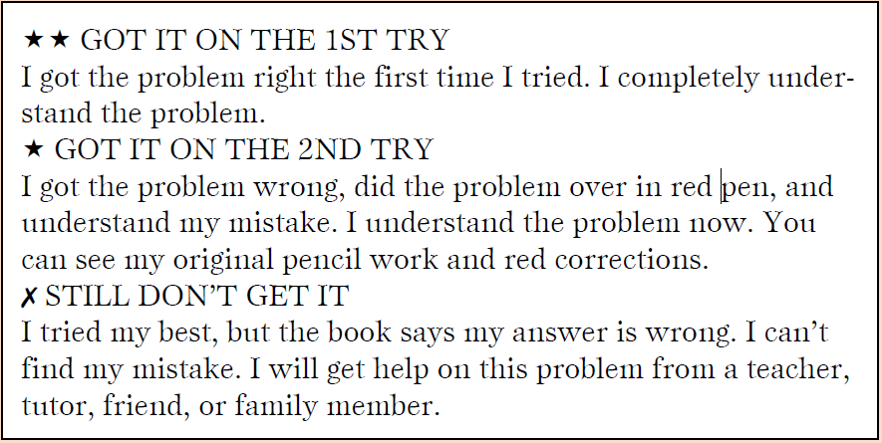
Step 4: Repeat this process for each problem.
Step 5: At the top of your homework, write a fraction showing how many of the problems you understand (1st or 2nd try both count) out of how many problems were assigned.

